Running the application locally using flask and MySQL as database:

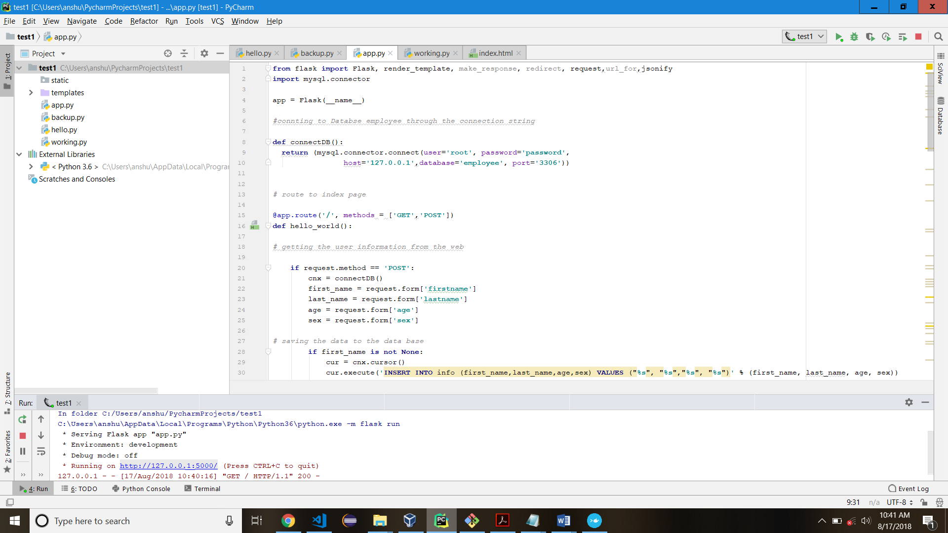

Using the employee database and info table and adding the data through the web interface:

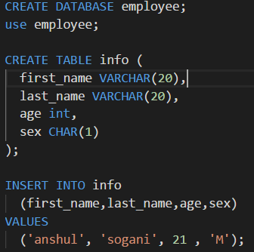

Adding user information to the data dataset using the web interface:

1. Run the flask from command prompt/or IDE say port 5000
2. Open browser and go to line: <https://localhost:5000/>

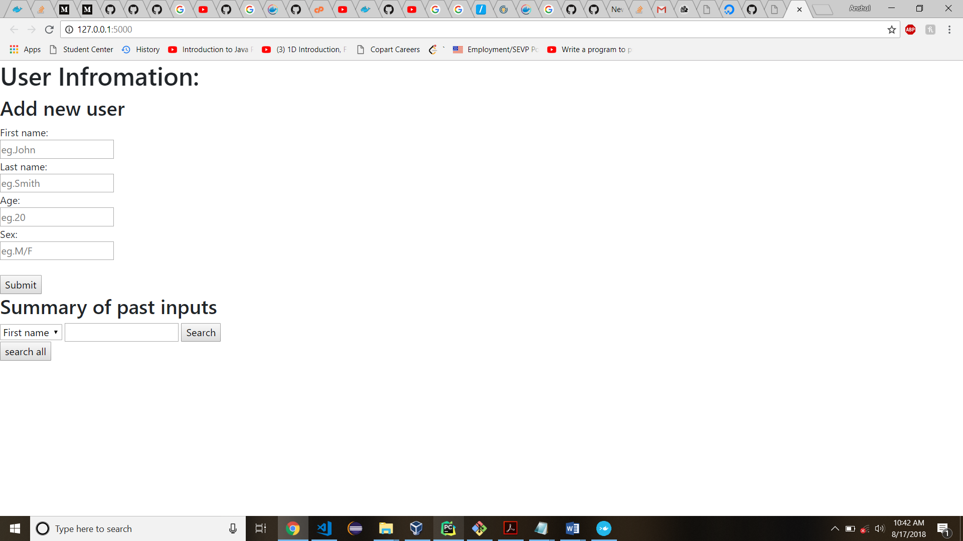

Data updated to the database:

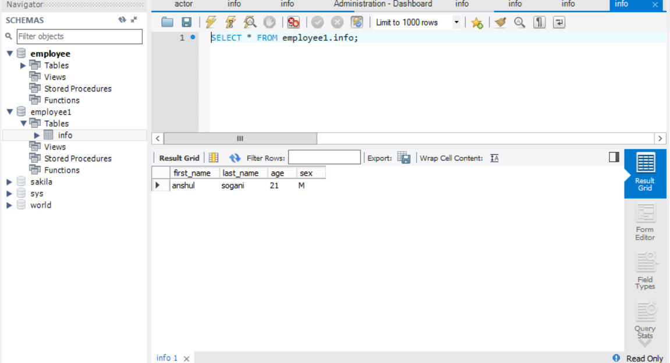

Fetching the result: summary on click using MySQL queries and displaying the desires output on the same window:

Fetching the average length, length of the name and count of same names received.

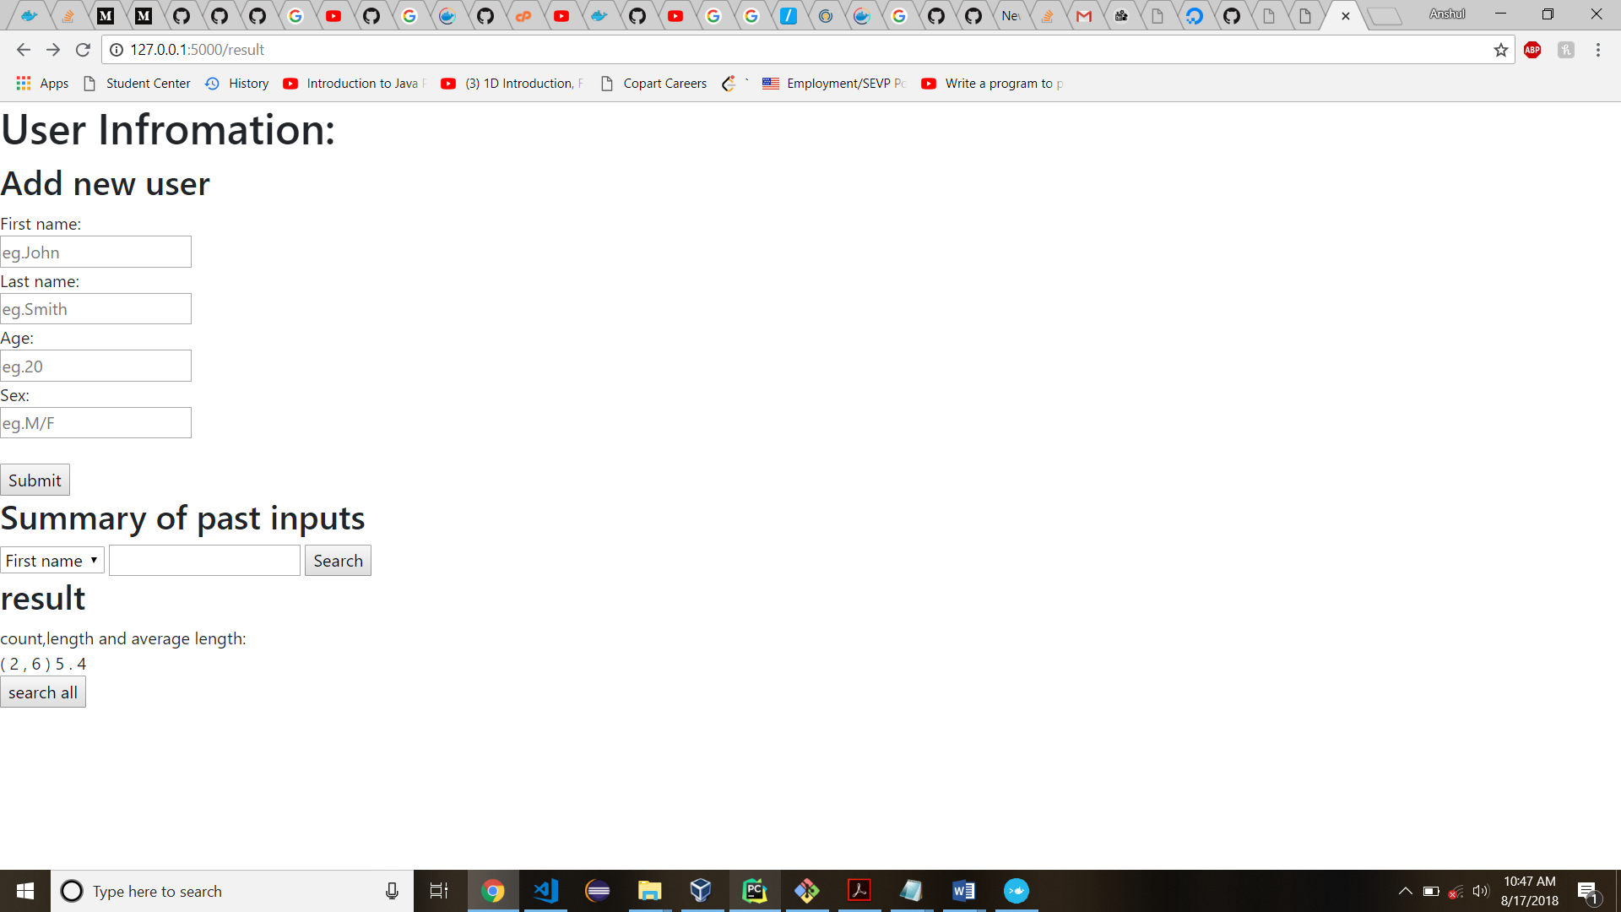

Getting the summary of all the past inputs:

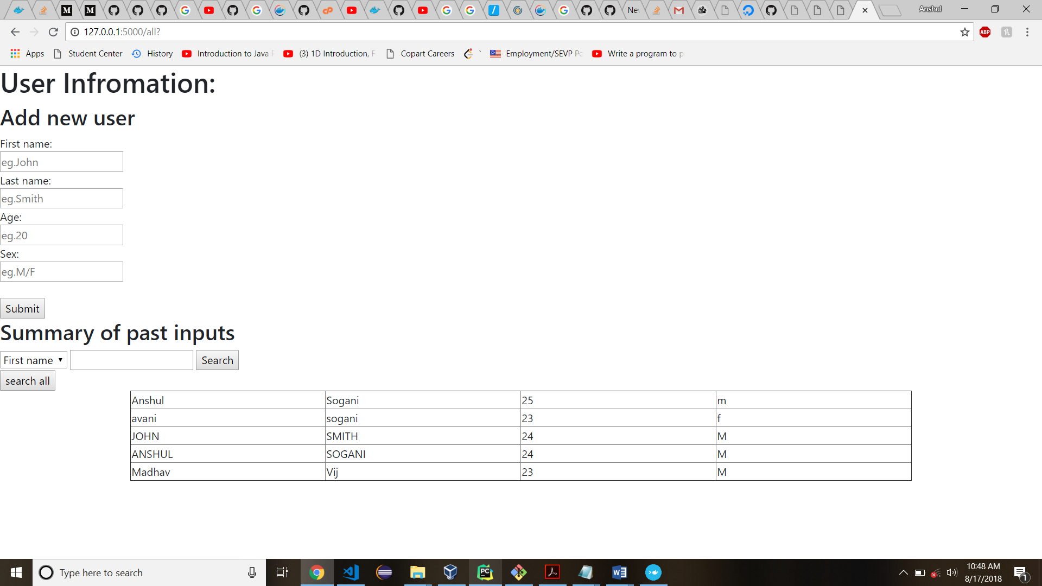

A rest Api call and Returning a json file with list of all users in the database:

